**High Level Design (HLD)**

**Shopping Cart Application**

Revision Number: 1.0

Last date of revision: 20/07/2023

Page-1

# Document Version Control

|  |  |  |  |
| --- | --- | --- | --- |
| **Date Issued** | **Version** | **Description** | **Author** |
| 20/07/2023 | 1 | Initial HLD — V1.0 | Vishal Katkar |
| 20/07/2023 | 2 | Updated KPI — V1.1 | Vishal Katkar |

Page-2

# Contents

Document Version Control

Abstract 2

1. Introduction 4
   1. Why this High-Level Design Document? 5
   2. Scope 5
   3. Definitions 5
2. General Description 5
   1. Product Perspective 6
   2. Problem statement 6
   3. PROPOSED SOLUTION 6
   4. FURTHER IMPROVEMENTS 6
   5. Technical Requirements 6
   6. Data Requirements 6
   7. Tools used 7
      1. Hardware Requirements 8
      2. ROS(Robotic Operating System) 8
   8. Constraints 9
   9. Assumptions 9
3. Design Details 9 3.1 Process Flow 10
   * 1. Model Training and Evaluation 10
     2. Deployment Process 10
   1. Event log 11
   2. Error Handling 11
   3. Performance 11
   4. Reusability 12
   5. Application Compatibility 12
   6. Resource Utilization 12
   7. Deployment 12
4. Dashboards 12
   1. KPIs (Key Performance Indicators) 13
5. Conclusion 13

14

Page-3

# Abstract

This high-level design document outlines the Shopping Cart Application, a platform designed to allow users to manage buying products. Users can browse through different categories, view, compare product costs and features, and make purchases. The document provides an in-depth analysis of the project's problem statement, proposed solution, technical requirements, and design details.

Page-4

# 1 Introduction

**1.1 Why this High-Level Design Document?**

The purpose of this document is to provide a comprehensive understanding of the Shopping Cart E Commerce Application's design and architecture. It serves as a reference for the development team, stakeholders, and other involved parties, ensuring a clear vision and shared understanding of the project.

The HLD will:

* Present all of the design aspects and define them in detail
* Describe the user interface being implemented
* Describe the hardware and software interfaces
* Describe the performance requirements
* Include design features and the architecture of the project
* List and describe the non-functional attributes like: o Security o Reliability o Maintainability o Portability o Reusability

o Application compatibility o Resource utilization o Serviceability

## 1.2 Scope

The Shopping Cart Web Application aims to bridge the gap between rural towns and the global market by providing a platform for merchants to advertise and sell their products. Users can access a wide range of commodities, compare prices and features, and make informed purchasing decisions. This document covers the design aspects of both the admin and user modules.

## 1.3 Definitions

*Term* *Shopping Cart Web Application*

*Admin* Authorized personnel responsible for managing the Shopping Cart Web Application, including shop details and offers.

*Database* Collection of all the information monitored by this system

*User* Individuals who utilize the Shopping Cart Web Application to browse and make purchases.

Page-5

# 2 General Description

## 2.1 Product Perspective

The Shopping Cart Web Application functions as an independent platform that connects merchants and users. It integrates with databases to store product information, user data, and transaction details, ensuring a seamless interaction and efficient transaction processing.

## 2.2 Problem statement

Rural towns often struggle to reach a wider customer base for their commodities. The Shopping Cart Web Application aims to address this problem by providing a platform where merchants can advertise and sell their products to a global audience, expanding their reach and improving business prospects.

## 2.3 PROPOSED SOLUTION

The proposed solution is the development of the Shopping Cart Web Application. It enables merchants to create and manage shop details, offers, and products. Users can browse products by category, compare costs and features, and make purchases. The application focuses on providing a secure and user-friendly platform for both merchants and users.

## 2.4 FURTHER IMPROVEMENTS

While the initial implementation fulfills the core requirements, future enhancements can be considered to enhance the Shopping Cart Web Application's functionality. Potential improvements include incorporating user reviews and ratings, implementing personalized recommendations, and integrating with popular payment gateways for seamless transactions.

## 2.5 Technical Requirements

The Shopping Cart Web Application utilizes the following technologies:

**HTML**: It is a Hyper text markup language used to design the basic structure of website.

**CSS**: It is cascading style sheet used to modify html content in website to make it look dynamic.

**JS**: Standard web development technologies for designing and building the user interface and interactivity.

**Node.js**: A JavaScript runtime environment that enables server-side development.

**React**.js: It is Used for the component based development of the project.

**Redux Toolkit** : It is used for the state management to keep changes in your app more predictable and tracable.

Page-6

## 2.6 Data Requirements

The Shopping Cart Web Application requires the storage and management of various data types, including shop details, product information, user profiles, and transaction history.

There are numerous image file formats out there and some of them is used to build our super mall web application.

o **JPEG -** Joint photographic experts' groups o **PNG —** portable network graphics o **SVG —** Scalable Vector Graphics

* JPEG is a lossy format meaning that the image is compressed to make a smaller file but this loss is not noticeable.
* PNG are a lossless image format; these files are able to handle up to 16 million colours unlike the 256 colours supported by GIF.
* A Scalable Vector Graphic (SVG) is a unique type of image format. Unlike other varieties, SVGs don’t rely on unique pixels to make up the images you see. Instead, they use ‘vector’ data.

## 2.7 Tools used

My project super mall web application is creaed by the help of mern stack which includes various types of tools, modules & coding skills like javascript, database connectivity, express, node etc. Some tules used are mentioned below:

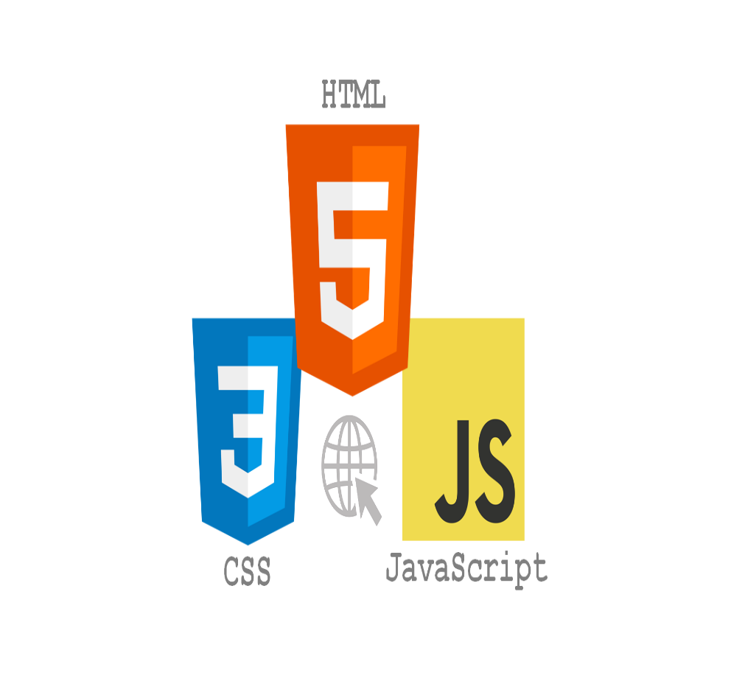 

Page-7

**The React.js framework is an open-source JavaScript framework and library developed by Facebook. It’s used for building interactive user interfaces and web applications quickly and efficiently with significantly less code than you would with vanilla JavaScript.**

**In React, you develop your applications by creating reusable components that you can think of as independent Lego blocks. These components are individual pieces of a final interface, which, when assembled, form the application’s entire user interface.**

**React’s primary role in an application is to handle the view layer of that application just like the V in a model-view-controller (MVC) pattern by providing the best and most efficient rendering execution. Rather than dealing with the whole user interface as a single unit, React.js encourages developers to separate these complex UIs into individual reusable components that form the building blocks of the whole UI. In doing so, the ReactJS framework combines the speed and efficiency of JavaScript with a more efficient method of manipulating the DOM to render web pages faster and create highly dynamic and responsive web applications.**

**Redux allows you to manage your app’s state in a single place and keep changes in your app more predictable and traceable. It makes it easier to reason about changes occurring in your app. But all of these benefits come with tradeoffs and constraints. One might feel it adds up boilerplate code, making simple things a little overwhelming; but that depends upon the architecture decisions.**

**One simple answer to this question is you will realize for yourself when you need Redux. If you’re still confused as to whether you need it, you don’t. This usually happens when your app grows to the scale where managing app state becomes a hassle; and you start looking out for making it easy and simple.**

Page-8

## 2.8 Constraints

The Shopping Cart Web Application should be designed to handle a moderate level of user traffic and concurrent transactions without compromising performance.

The development process should adhere to budgetary and timeline constraints defined for the project.

## 2.9 Assumptions

Users have basic internet connectivity and access to a web browser to utilize the Shopping Cart Web Application.

The Shopping Cart Web Application will be compatible with popular web browsers, ensuring widespread accessibility.

Page-9

# 3 Design Details

## 3.1 Process Flow

The Shopping Cart Web Application follows the following process flow:

Admin manages shop details, offers, and products.

Users browse products by category.

Users view shop details, offers, and compare product costs and features.

## 3.2 Event log

The Shopping Cart Web Application includes an event logging mechanism to track and analyze user actions. Events such as login attempts by users or customers.

**Initial Step-By-Step Description:**

1. The System identifies at what step logging required
2. The System should be able to log each and every system flow.
3. Developer can choose logging method. You can choose database logging/ File logging as well.
4. System should not hang even after using so many loggings. Logging just because we can easily debug issues so logging is mandatory to do.

## 3.3 Error Handling

My web application incorporates error handling mechanisms to handle exceptions gracefully. User-friendly error messages are displayed when appropriate, and detailed error logs are maintained for troubleshooting and issue resolution.

Page-10

# 4 Performance

Performance optimization is a crucial aspect of the Shopping Cart Web Application. Techniques such as caching, database indexing, code optimization, and load balancing are employed to ensure optimal response times, scalability, and high availability.

## 4.1 Reusability

Code components and modules are designed with reusability in mind to promote efficient development and maintenance. Modular code practices, adherence to design patterns, and clear documentation facilitate code reuse across different sections of the Shopping Cart Web Application.

## 4.2 Application Compatibility

The Shopping Cart Web Application is designed to be compatible with popular web browsers and devices. Responsive design principles and compatibility testing ensure consistent user experiences across various platforms and screen sizes.

## 4.3 Resource Utilization

Efficient utilization of system resources is a consideration in the design and implementation of Shopping Cart Web Application. Techniques such as memory management, optimized queries, and proper resource allocation are employed to maximize resource efficiency.

## 4.4 Deployment

The Shopping Cart l Web Application is deployed to a production environment following industry best practices. Server configuration, security measures, performance optimizations, and automated deployment processes are implemented to ensure a smooth and reliable deployment.

Page-11

## 5 Dashboards

### 5.1 KPIs (Key Performance Indicators)

1. Number of active shops
2. Customer satisfaction ratings
3. Shop performance metrics (e.g., number of products sold, revenue per shop)
4. Product popularity and demand (e.g., most viewed products, most purchased products)
5. Website traffic metrics (e.g., unique visitors, page views)
6. Average response time for user interactions (e.g., page loading time, search query response time)

# 6 Conclusion

In conclusion, the Shopping Cart Web Application is a platform that enables merchants to manage their shop's offers, products, and location, while providing users with a comprehensive shopping experience. This high-level design document has provided an overview of the project's problem statement, proposed solution, technical requirements, and design details. It serves as a valuable resource for the development team, stakeholders, and other parties involved in Shopping Cart Web Application project.

Page-12

# 7 References

1. Sharma, Avnish Kumar. "BIG BUY (E-Commerce website) by using Frontend Web

Development." *International Journal for Modern Trends in Science and Technology* 7 (2021): 201-208.

1. Naidu, Nagothu Diwakar, et al. "E-Commerce web Application by using MERN Technology." *International Journal for Modern Trends in Science and Technology* 7.05 (2021): 1-5.

1. [Raju, Saravanan, S. Soundararajan, and V. Loganathan. "Mern stack web application." *Annals of the Romanian Society for Cell Biology* 25.6 (2021): 6325-6332.](https://www.ros.org/)

1. [Badru, Lawal Olarotimi, et al. "MERN stack web-based education management information systems for Pacific Island countries." *SN Computer Science* 4.1 (2022): 70.](https://www.ros.org/)

1. [Sandhya, M., and S. Shivleela. "Quick-Store Using MERN." *International Research Journal of Innovations in Engineering and Technology* 6.6 (2022): 191.](https://www.ros.org/)

1. [Panchal, Rahul Sanjay, et al. "NFT-Driven B2C E-Commerce Website Innovation: A Study of the Effects of Blockchain Integration in the Deep Web."](https://www.ros.org/)

Page-11